GovPayNet
Clearing the Cache in Major Browsers

Firefox
- Hold down Control + Shift + Delete while in the Firefox browser (or select History > Clear Recent History from the toolbar).
- On the Clear Recent History pop-up, you will need to adjust the Time range to clear and expand the Details box to specify what to clear.

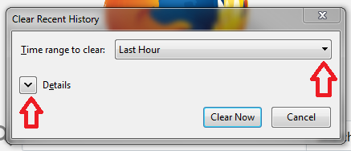

- Choose Everything for the time range to clear and make sure the boxes are checked to clear Browsing & Download History as well as Cache.
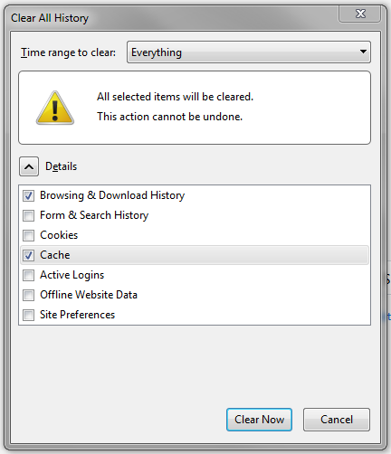

- Click Clear Now and restart your browser once the data has been cleared.
Chrome
- Hold down Control + Shift + Delete while in the browser (or at the top right choose Menu > Settings > Privacy > Clear Browsing Data)
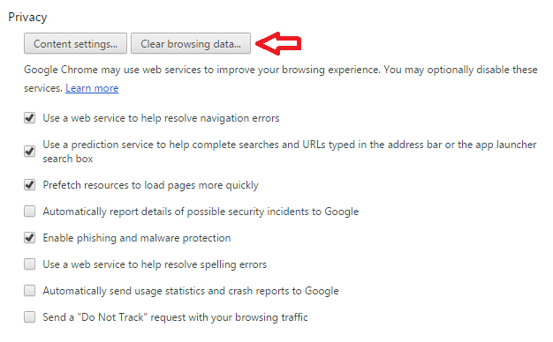
- In the Clear browsing data popup, choose the beginning of time for the time frame and make sure Cached images and files is checked.
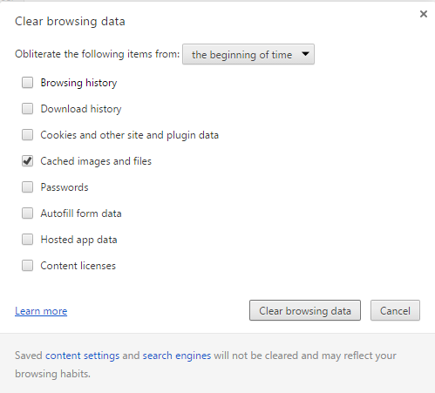
- Select Clear browsing data and restart your browser once the data has been cleared.

Internet Explorer
- In the browser, hold Control + Shift + Delete (or select Tools > Delete Browsing History) to bring up the popup.
- In the Delete Browsing History tab, make sure to uncheck the top box that says Preserve Favorites website data and then make sure to check Temporary Internet files and website files.

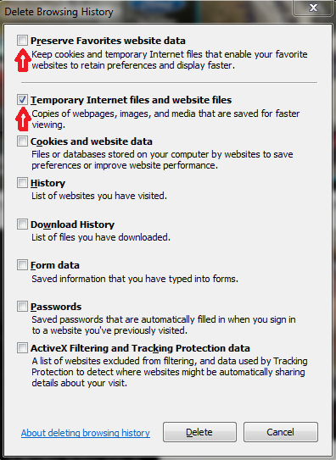

- Click Delete to clear the data and restart your browser once the data has been cleared.

